FIGURES

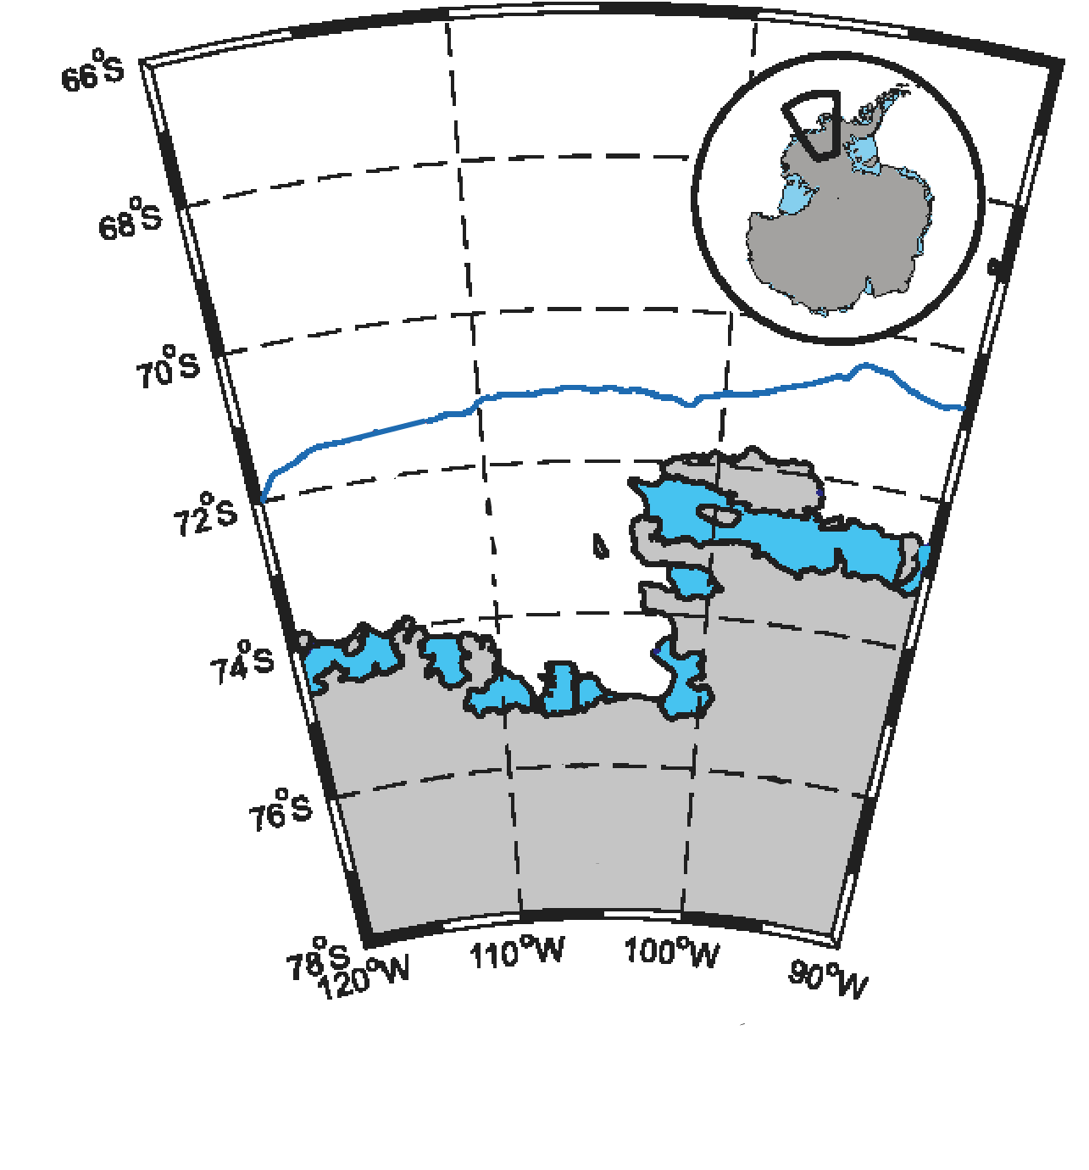

1000 m

Amundsen Sea embayment

Dotson

Thwaites

Pine

Island

**Figure 1A.** Map of the Amundsen Sea Embayment (modified from Walker et al. 2007).

*Southern Ocean*

**Figure 1B.** MODIS satellite image (*nsidc.org/data/iceshelves_images*) from Feb 2019 of southeastern Amundsen Sea with its two notable polynyas labeled in green and five rapidly melting ice shelves labeled in yellow.

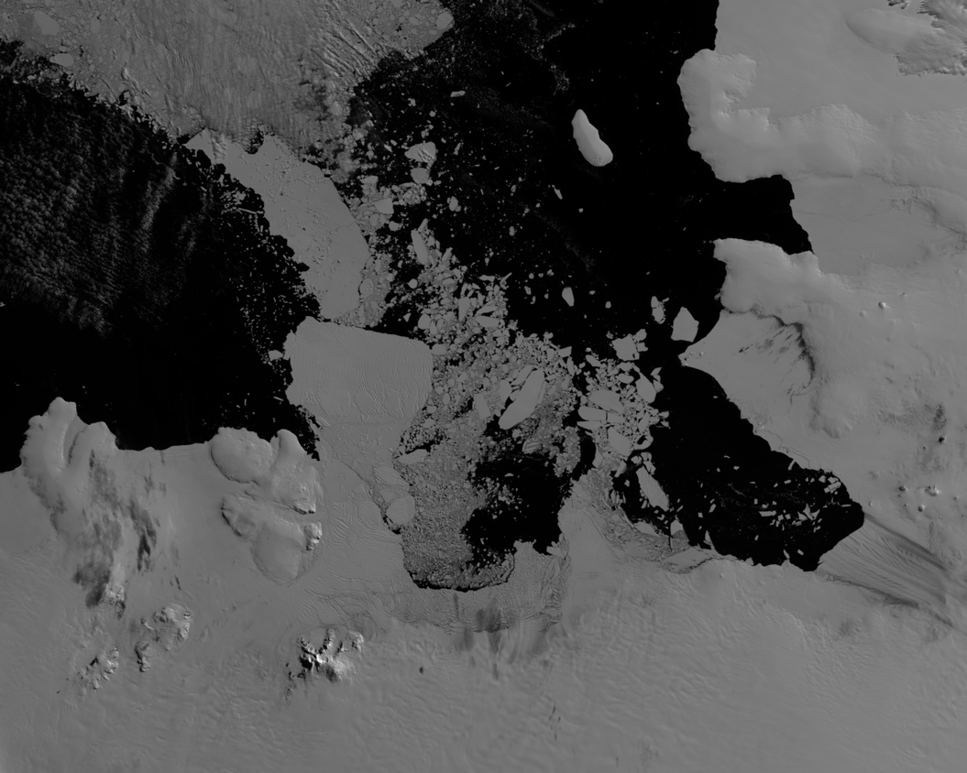

Cosgrove

Pine

Island

Thwaites

Dotson

Crosson

Amundsen Sea Polynya

Pine Island Polynya

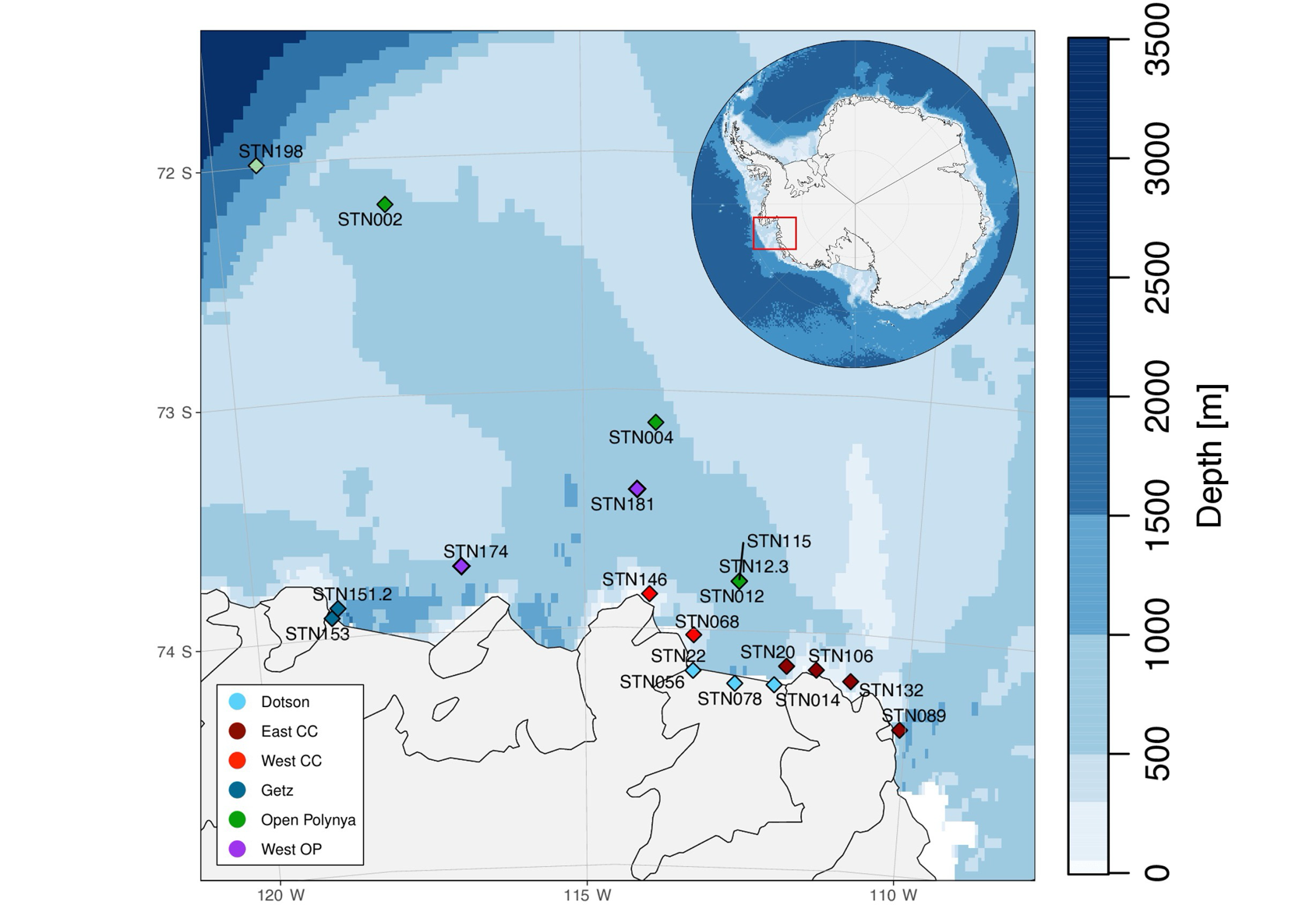

Dotson

**Figure 2.** Station map with bathymetry. Colors are coordinated with location.

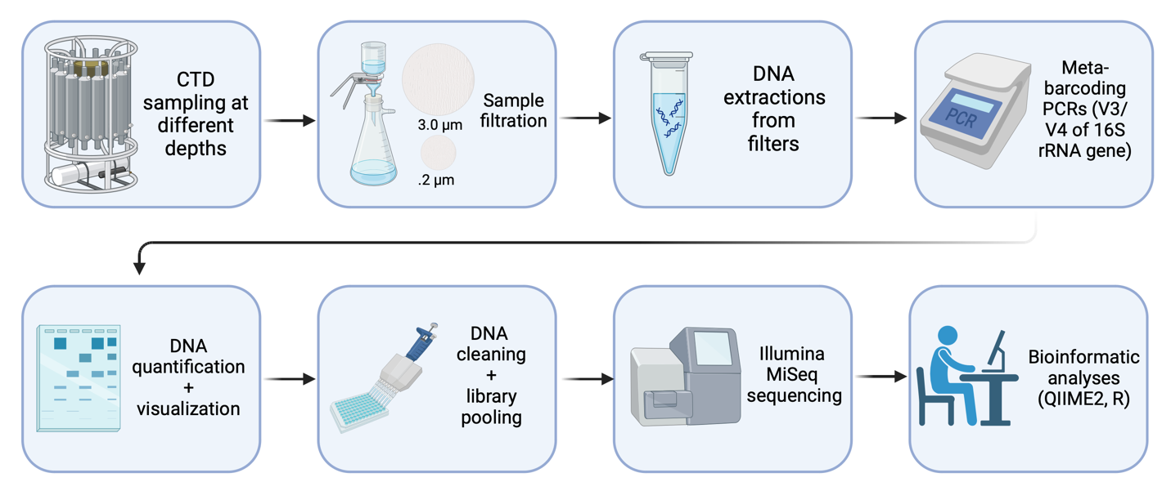

**Figure 3.** Pipeline of study.



**Figure 4.** Temperature-Salinity plot for all ARTEMIS CTD casts, with oxygen as color and black points as samples with DNA collected.

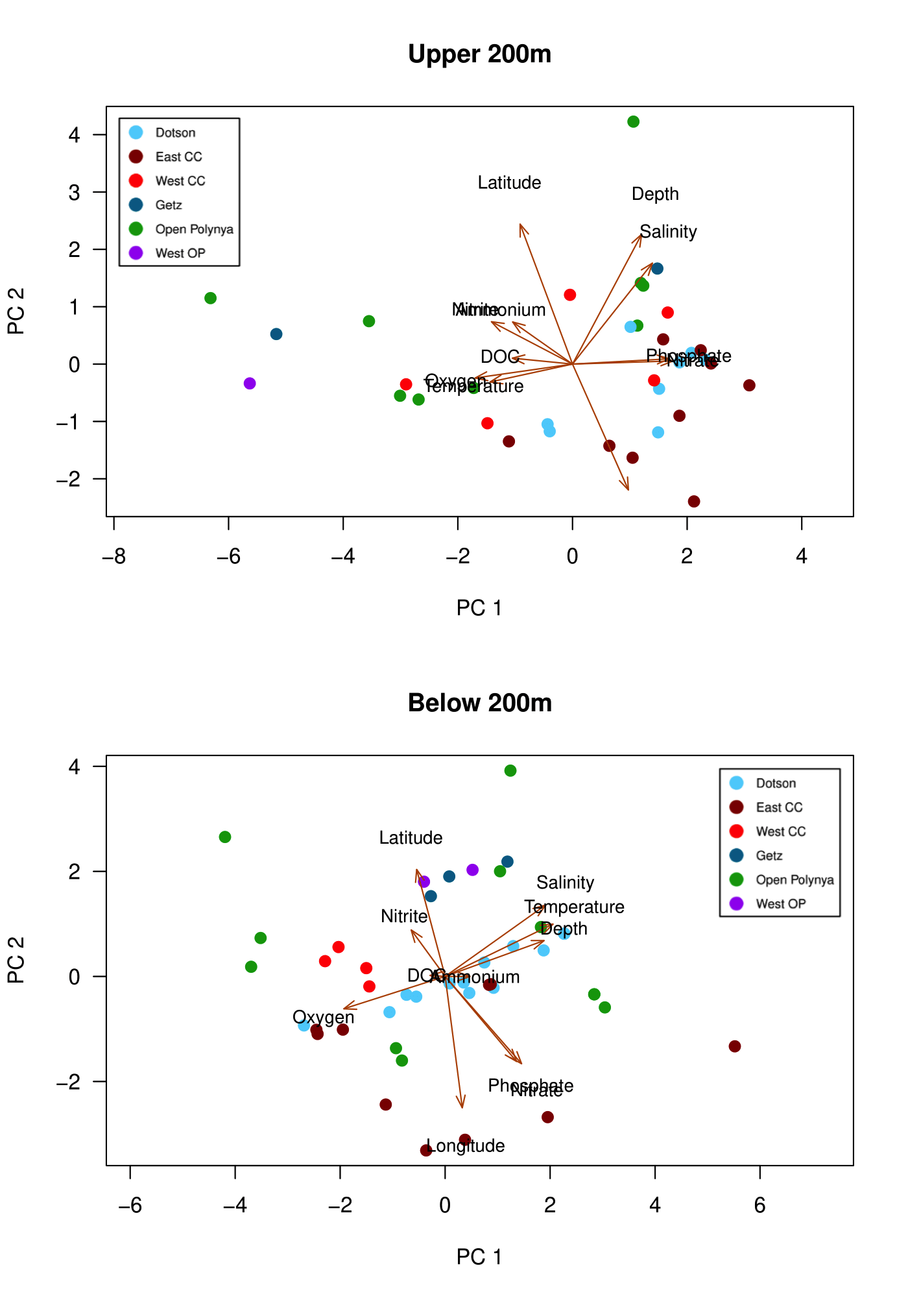

**Figure 5.** PCA of sample metadata by location in the ASP. Top PCA is surface-200m and bottom PCA is 200-bottom.

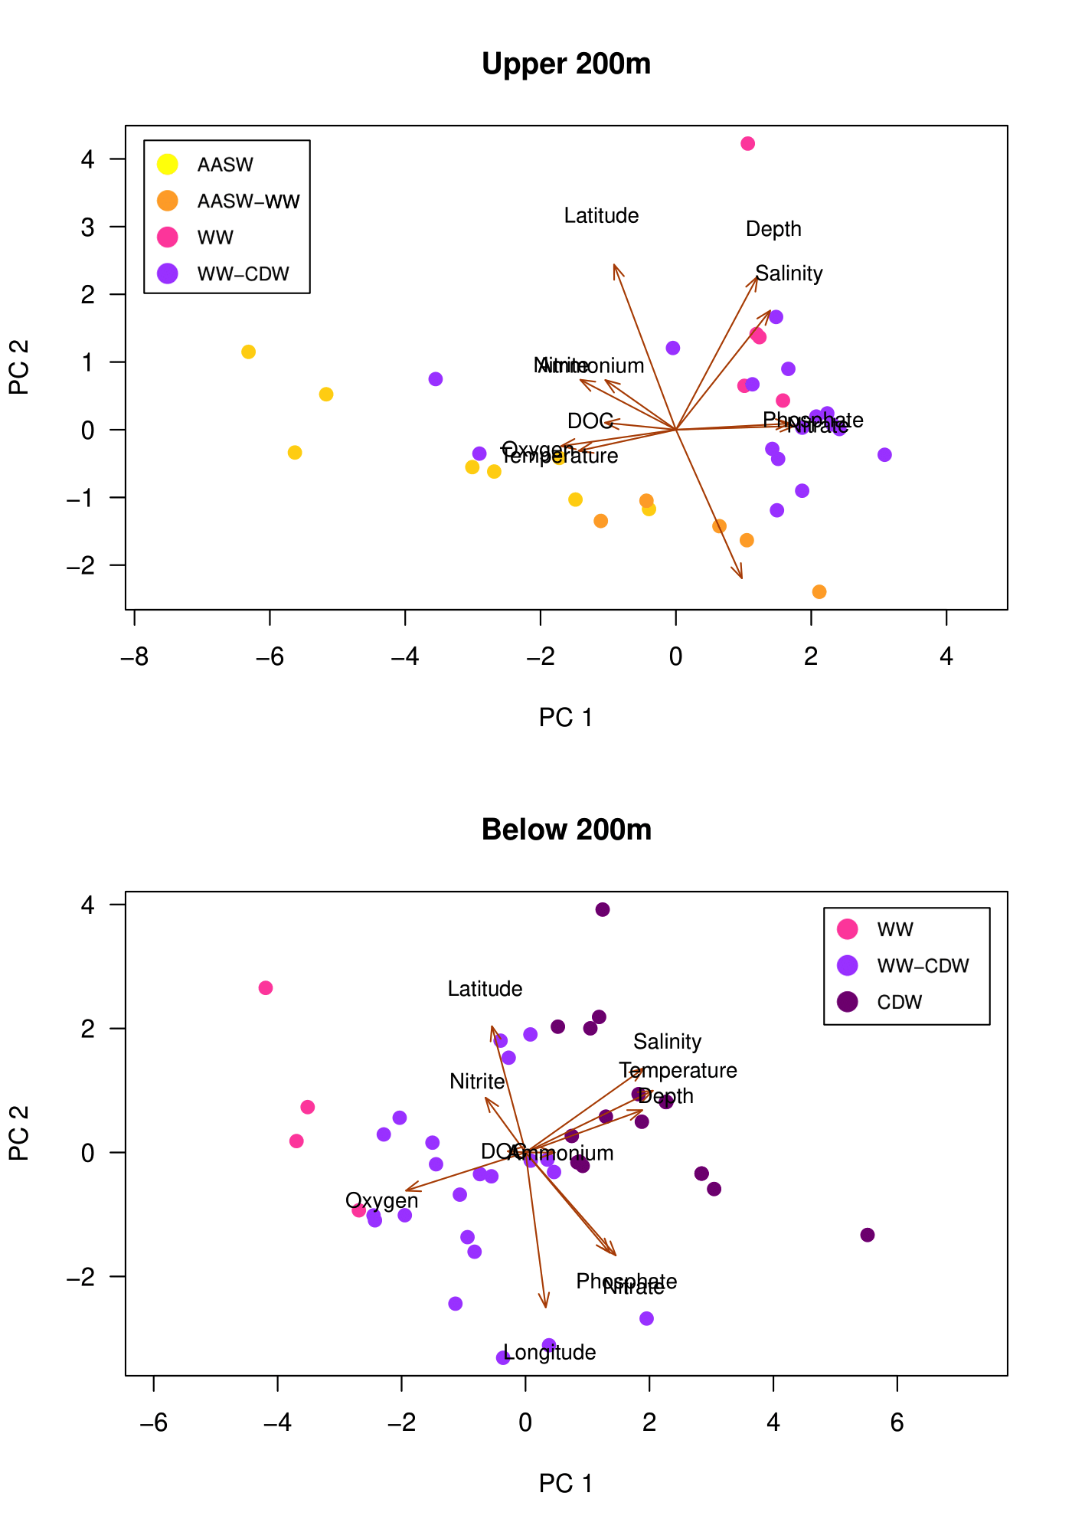

**Figure 6**. PCA of sample metadata by water mass in the ASP. Top PCA is surface-200m and bottom PCA is 200 m to seafloor.

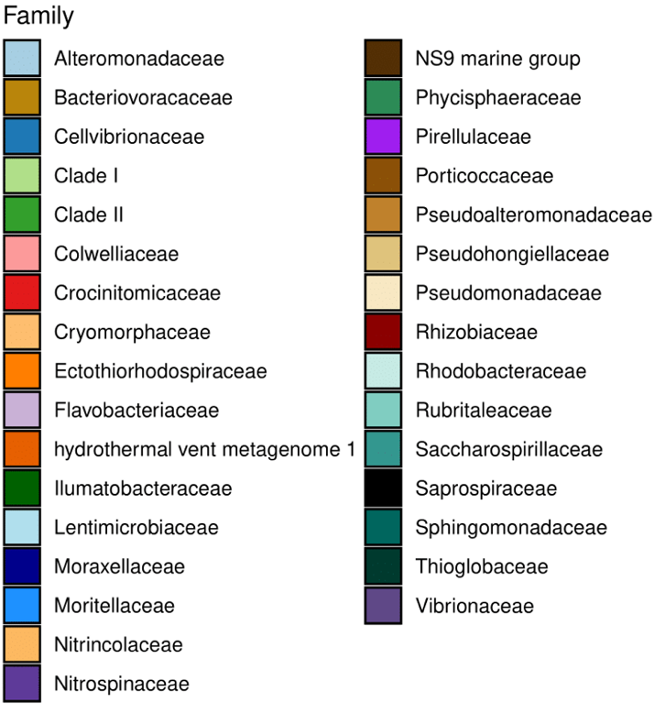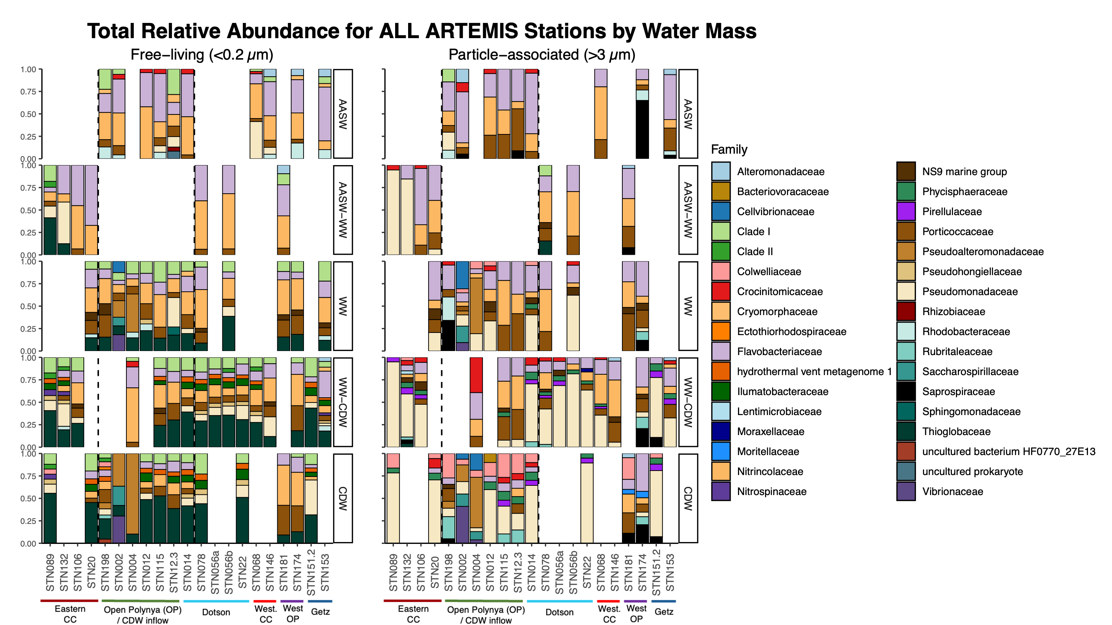

**Figure 7A.** Relative abundance for free-living (left) and particle-associated (right) communities at the family level. Each row represents a water mass, labeled on the right.

**Figure 7B.** Legend for the Family-level taxa that corresponds with **Figure 7A**.

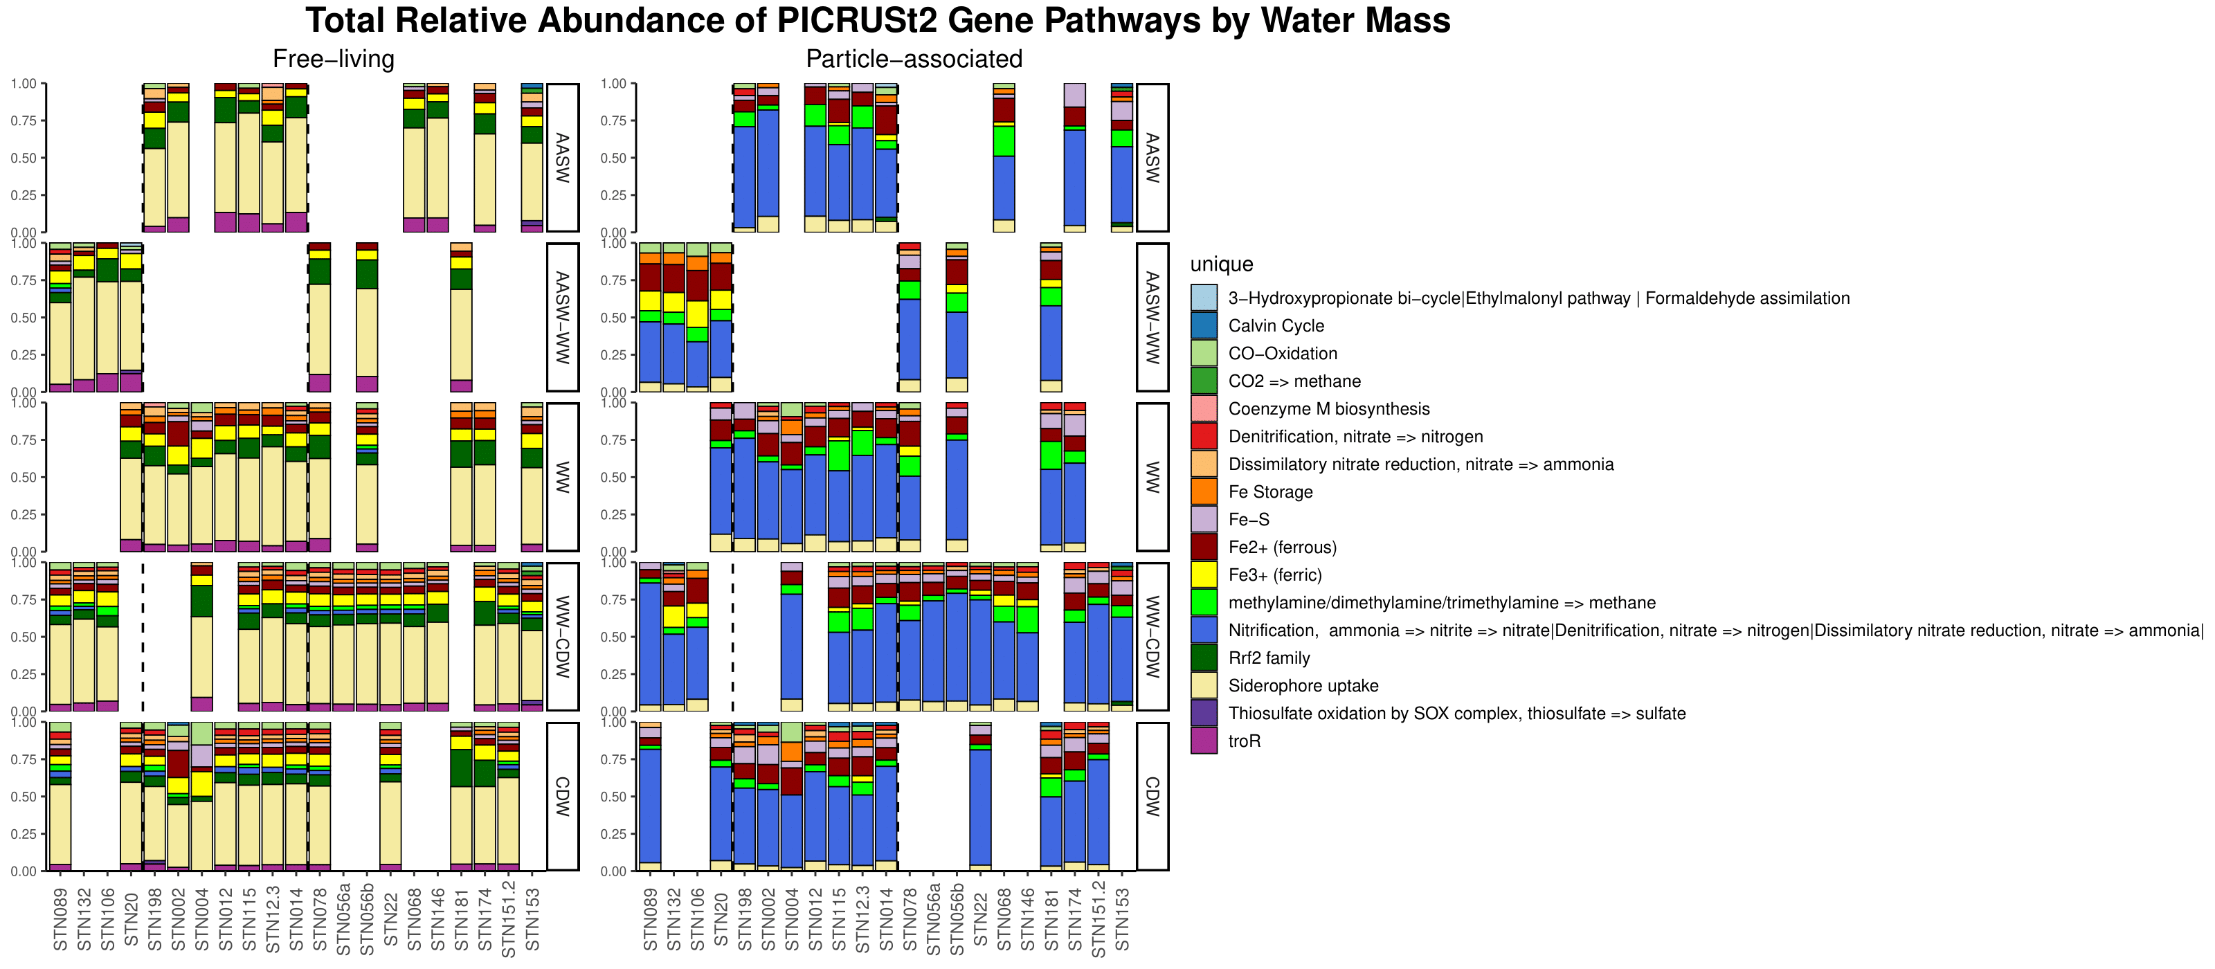

**Figure 8A**. Relative abundance of PICRUSt2 KO numbers by water mass and station. Free-living on left and particle-associated on the right.

**Figure 8B.** Legend that corresponds to **Figure 8A.**

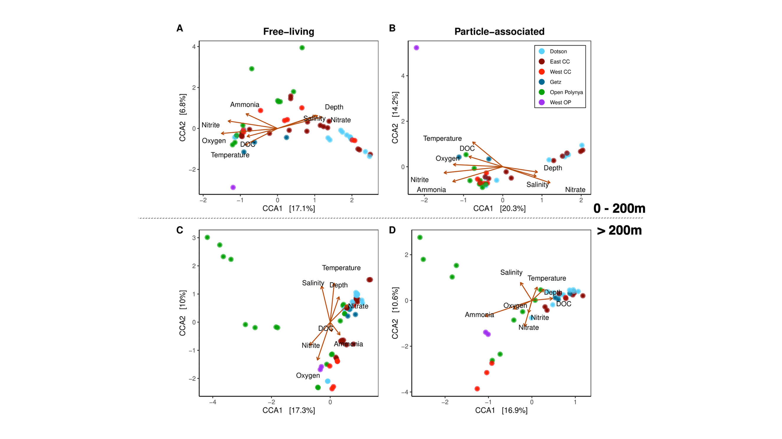

**Figure 9.** Canonical Correspondence Analysis (CCA) of free-living (**A, C**) and particle-associated (**B, D**) bacterial communities based on **location** within the ASP. First row CCAs are surface-200m and bottom row CCAs are 200m-bottom.

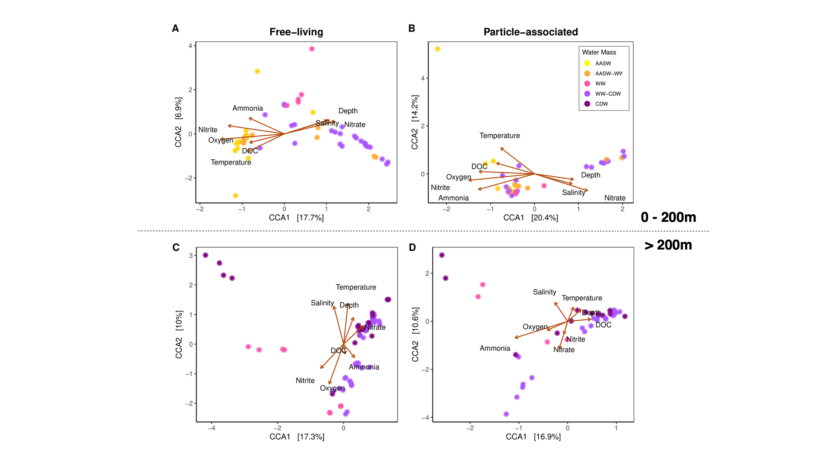

**Figure 10**. Canonical Correspondence Analysis (CCA) of free-living (**A, C**) and particle-associated (**B, D**) bacterial communities based on defined **water mass**. First row CCAs are surface-200m and bottom row CCAs are 200m-bottom.



**Figure 11.** Relative abundance by water mass and station at the Family level, including Archaea. Similar to previous relative abundance plots (Figure 7; Figure 8) but includes prevalence of *Nitrosopumilaceae*, a known ammonia-oxidizing archaea.

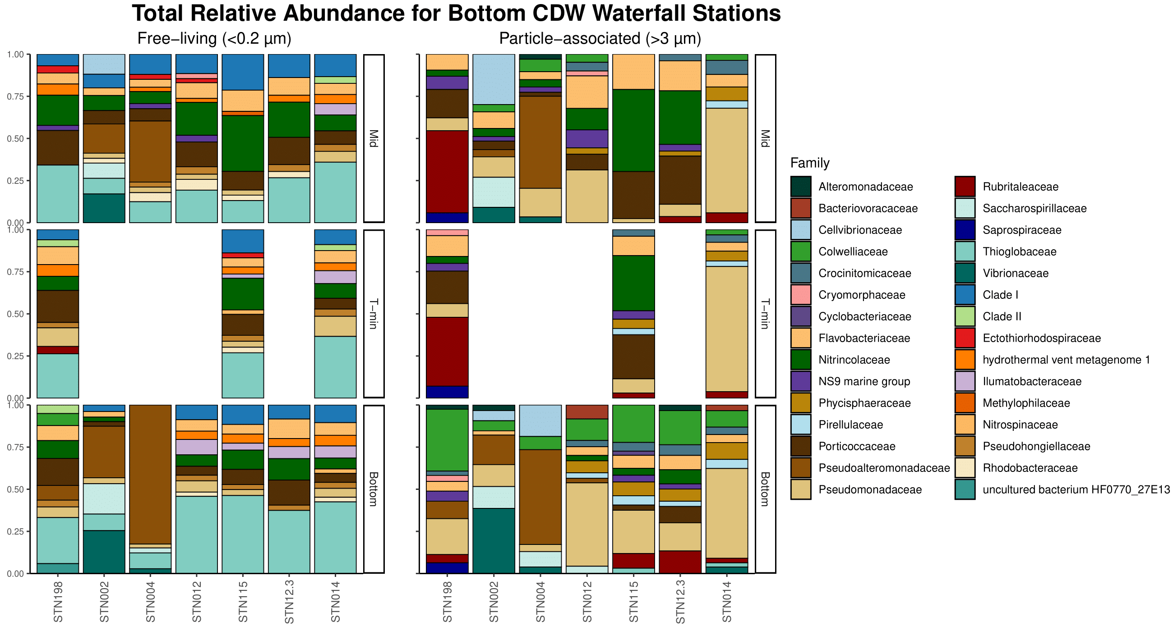

**Figure 12.** Relative abundance of stations coming from off the continental shelf at the family level. Free-living on left and particle-associated on the right.

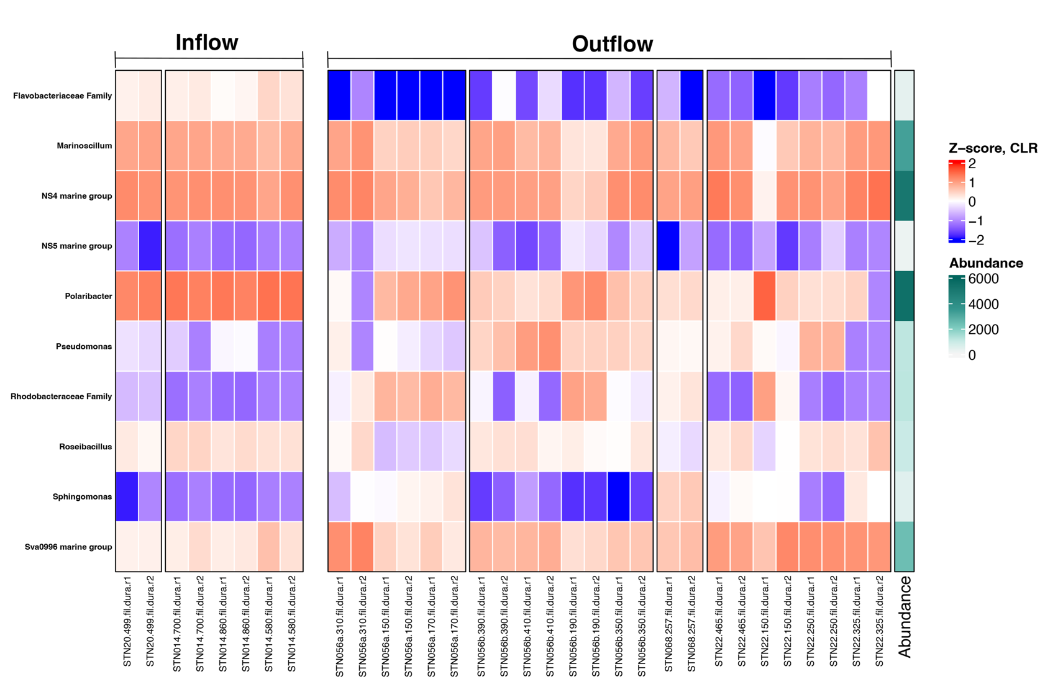

**Figure 13.** Significant **free-living** taxa from ANCOM-BC analysis for inflow vs. outflow samples. Z-score derived from log-transformed data. No significant change in particle-associated taxa from ANCOM-BC analysis.

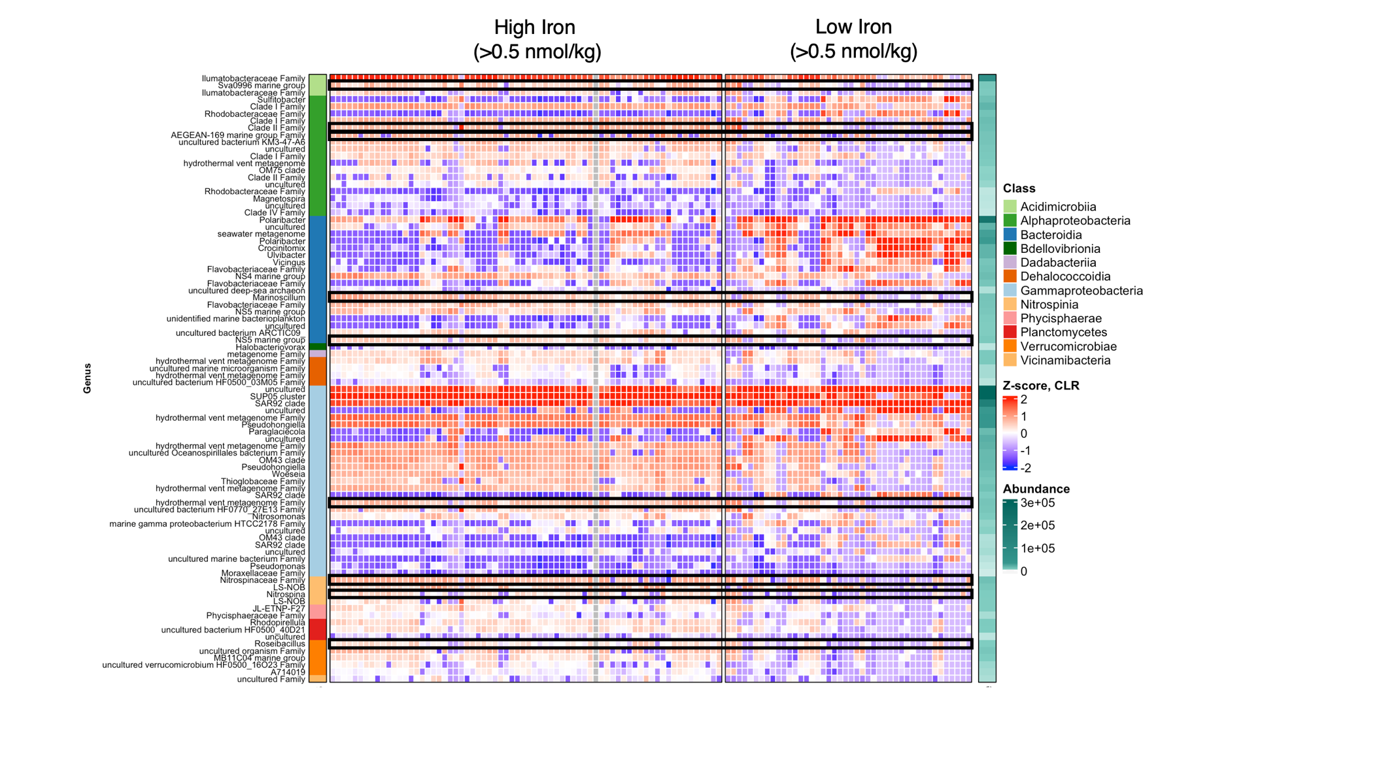

**Figure 14.** Significant **free-living** taxa from ANCOM-BC analysis for high (>0.5 nmol/kg) or low (<0.5 nmol/kg) dFe concentrations. Z-score derived from log-transformed data. Black boxes indicate taxa that are more present in high iron versus low iron.

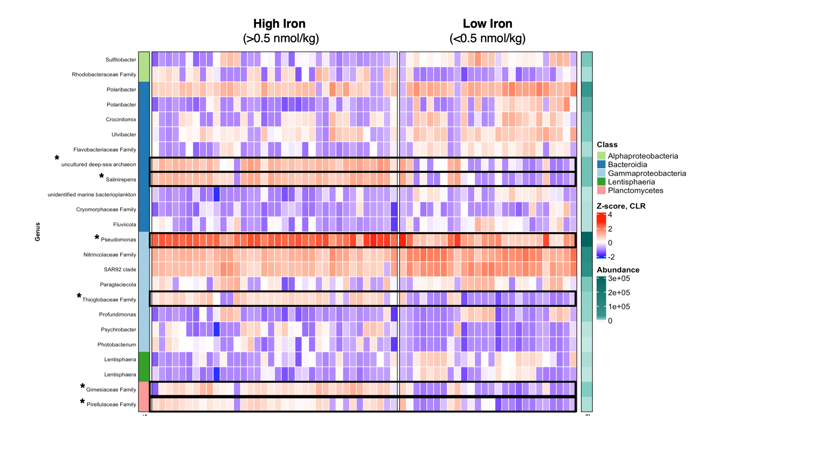

**Figure 15**. Significant **particle-associated** taxa from ANCOM-BC analysis for high (>0.5 nmol/kg) or low (<0.5 nmol/kg) dFe concentrations. Z-score derived from log-transformed data.

TABLES

**Table 1.** Water mass characterization with temperature and salinity ranges.

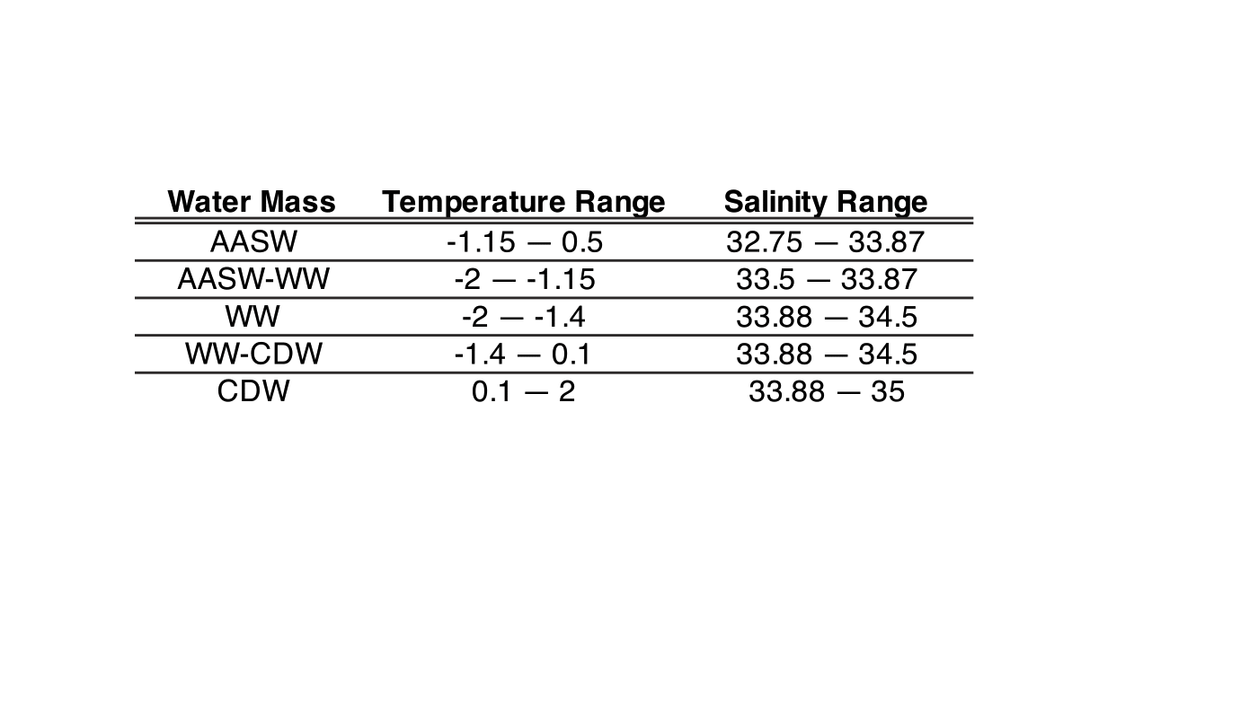

**Table 2**. Inflow and outflow stations and depth.

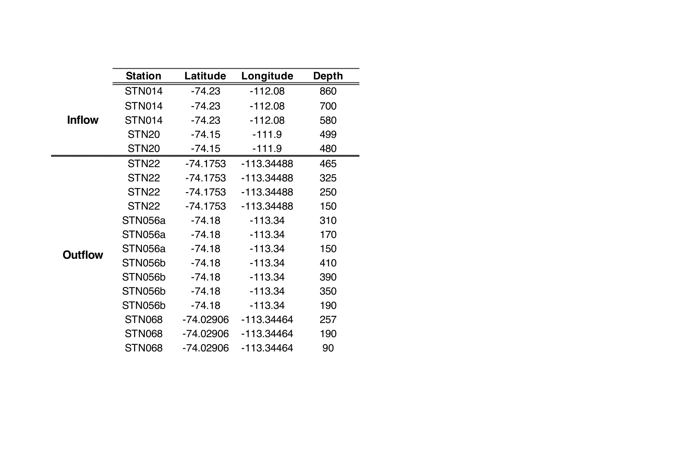

**Table 3.** Indicator species analysis of significant taxa in **free-living** outflow community. No significant indicator taxa appeared for particle-associated community.



**Table 4.** Indicator species for **free-living** communities based on location, separated into surface-200m (upper 200m) and 200-bottom (below 200m).

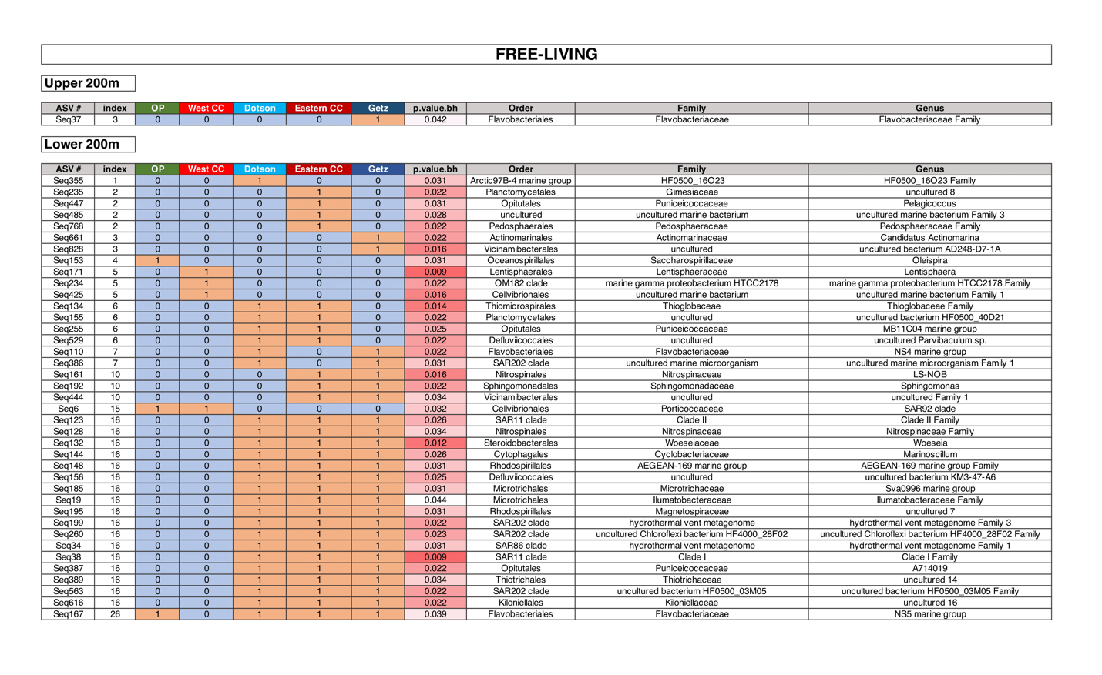

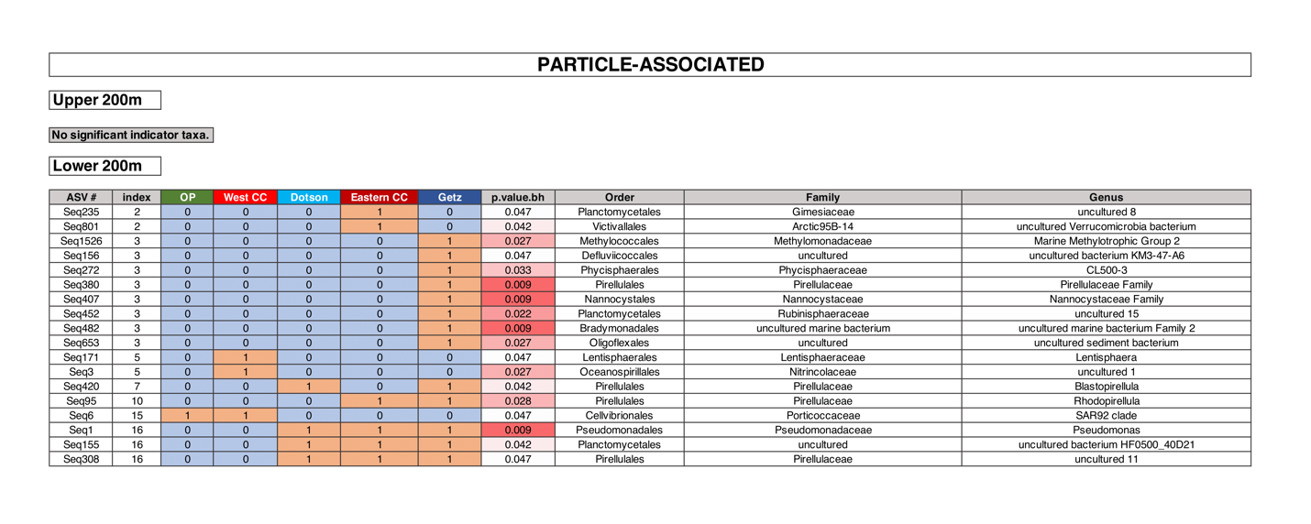

**Table 5.** Indicator species for **particle-associated** communities based on location, separated into surface-200m (upper 200m) and 200-bottom (below 200m). No significant taxa for upper 200m.

APPENDIX



**Table S1**. Taxonomy table for unique taxonomic ranks going to species.





**Table S2**. Metadata table for size-fractionation and environmental data for each sample.

